**Experiment Name :- Yagi-Uda 3E**

*Student Name :- Mr.Shirsh_Shibu_Shivam*

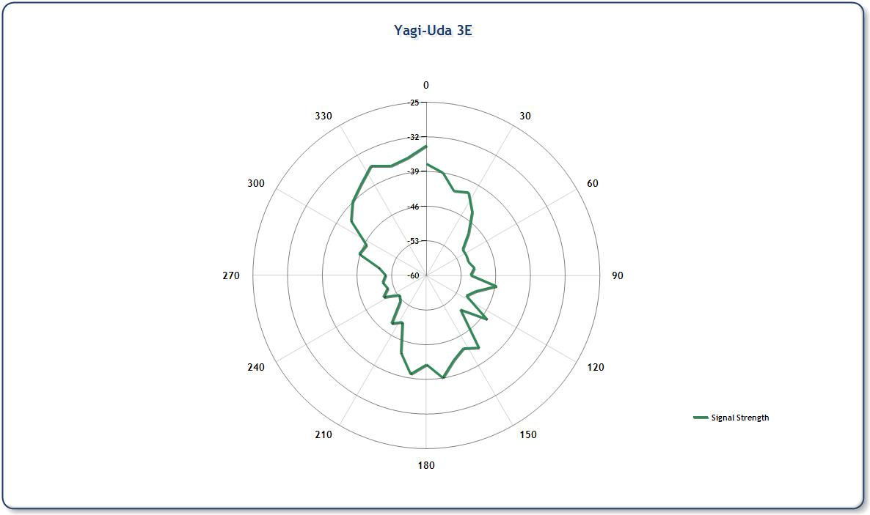

*signature of class teacher*